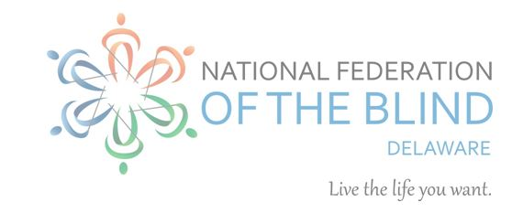

2025 NFBDE SCHOLARSHIP APPLICATION

Each year the National Federation of the Blind of Delaware (NFBDE) awards scholarships to qualified blind students. The scholarships are awarded at the annual convention of the NFBDE. In 2025 the NFBDE will award several scholarships of at least $600 each.

## Criteria:

All scholarships are awarded on the basis of academic excellence and service to the community.  To be eligible for an NFBDE scholarship, an applicant must be a legally blind resident of Delaware who is enrolled full-time in an accredited two-year, four-year or graduate college or university program.

## Application Process:

To apply, please complete the application below. Send proof of blindness, transcripts, recommendation letter, and any other support for your application via email to Sylvia Reid, NFBDE Affiliate President; shevra@verizon.net

Direct questions to

June Hunter-Hardy, Chair, NFBDE Scholarship Committee Email [nosmoke0302@gmail.com](mailto:nosmoke0302@gmail.com) or call 718-483-0525

Accessible documents in MSWord or RTF are preferred for recommendation letters and proof of blindness. If your school has a transcript portal, simply send the login information.

## Deadline:

All application materials must be received between February 15 and May 15, 2025.

## General Information:

Persons who have previously applied for NFBDE scholarships are encouraged to apply again.  The Scholarship Committee reviews all applications and selects the scholarship finalists, who will be notified of their selection by August 31, and will be brought to the NFBDE convention in the fall.   Finalists must attend the NFBDE state convention, which is usually a day and a half, and may be virtual.

## NFBDE SCHOLARSHIP APPLICATION FORM

First Name

Last name

Any other names, maiden or other, you have used

Date of Birth

School Name

School Address {line one, line two, city, state, and zip}

School Phone

Home Address {line one, line two, city, state, and zip}

Home Phone

Cell phone

E-Mail Address

Please check off the following which apply to you.  If any do not apply to you, you are ineligible for an NFBDE scholarship at this time.

___ I am legally blind in both eyes.

___ I will attend college full time in the Fall.

___ I am a resident of Delaware.

Institution attended Fall 2024

Class standing in Fall of 2024, i.e. Freshman, Sophomore.

Cumulative GPA

All post-secondary institutions you have attended with highest class standing attained and cumulative grade point average,

Personal Essay: Introduce yourself to the scholarship committee in a brief (500 or fewer words) essay. Consider the essay an opportunity to tell the committee who you are. Describe your strengths, achievements, and aspirations. What is important to you? Who do you hope to become? Has a particular person or experience changed your life?   How has your blindness affected you?  How do you handle it at school, on the job, and in interpersonal relationships?  Keep in mind that this scholarship is not based on financial need so it should not be addressed in your essay.

{Confirmation Page}

Thank you for submitting your application for a National Federation of the Blind of Delaware scholarship. Please send the following documents to Affiliate President via email at shevra@verizon.net to complete your application:

One current letter of recommendation.

Doctor’s letter or medical report stating that you are legally blind in both eyes. Please do not send medical records. A brief statement of legal blindness suffices.

Transcripts: Provide a current transcript from the institution you are attending as well as transcripts from all post-secondary institutions you have attended. If you have not attended an institution of higher learning or have not completed one year of study at such an institution, provide a high school transcript.

Contact with questions via the email above or via phone at 302-743-8811.